Computer-Supported Teacher Development of Pedagogical Content Knowledge through Developing School-Based Curriculum
Yih-Ruey Juang
Department of Information Management
Jinwen University of Science and Technology
No. 99, An-jong Rd.,
Xin-dian City, Taipei, Taiwan 231, R. O. C.
TEL: +886-2-82122307
FAX: +886-2-82122339
yrjuang@just.edu.tw

Tzu-Chien Liu
Graduate Institute of Learning & Instruction
National Central University
No. 300, Jhong-da Rd.,
Jhong-li City, Tao-yuan, Taiwan 320, R. O. C.
TEL: +886-3-4227151 ext. 33851
FAX: +886-3-4273371
ltc@cc.ncu.edu.tw

Tak-Wai Chan
Graduate Institute of Network Learning Technology
National Central University
No. 300, Jhong-da Rd., Jhong-li City, Tao-yuan,
Taiwan 320, R. O. C.
TEL: +886-3-4227151 ext. 35400
FAX: +886-3-4261931
chan@cl.ncu.edu.tw

Abstract
Pedagogical content knowledge (PCK) is essential to career development for teachers. Teachers can develop their own PCK by research-based activities such as action research and lesson study, with a particular emphasis on the employment of classroom practice, information technology, and collaborative learning. However, most of the models that recent study brought up to enhance teachers’ PCK focus on individual teachers or teacher groups, and there is less chance of receiving support from the school leadership and institutional resources. This study proposes a development model for PCK known as the 3C-model and implements a supporting system for it, known as EDUPLAN. The model engages teachers in collaboratively constructing and sharing a knowledge-base of lesson plans with the involvement of different levels of school members for their school’s curriculum. Through the process of school-based curriculum development, the model was found to increase teacher PCK and collaboration. Finally, the supporting system is found to be capable of enhancing performance in lesson plan construction and revision and thus the efficiency of PCK development.
Keywords
Pedagogical Content Knowledge (PCK), lesson plan, School-Based Curriculum Development, Teacher Professional Development
Introduction
Pedagogical Content Knowledge (PCK), one of the most important bodies of knowledge a teacher must master, represents the blending of content and pedagogy into understanding, and is closely linked to the instructional practice of teachers (Shulman, 1986). PCK refers to the professional understanding of how to organize and present specific topics, problems, or issues for instruction according to student background, school educational goals, and educational context. However, PCK cannot be fully obtained from pre-service teacher education and must be developed subject by subject through long-term immersion in curriculum development and classroom practices (Borko et al., 1988). Since PCK is crucial for instructional professionals and is difficult to construct, enhancing teacher PCK is often regarded as the main objective of teacher professional development (Shulman, 1987; McDiarmid, Ball & Anderson, 1989; Tamir, 1990).
Furthermore, teachers can develop their own PCK by research-based activities, the application of learning in everyday classroom practice, information technology, and collaborative learning among teachers, resulting in growth of the PCK of teachers. Although there are numerous ways of research-based activities to support teachers in developing their own PCK, including action research and lesson study, most development models only emphasize collaboration/cooperation among teachers while neglecting the participation of other school members or internal organizations, such as the school curriculum development committee that can be involved in guiding teachers in performing research and providing relevant professional knowledge for acquiring PCK. Through school-wide activities, such as school-based curriculum development (SBCD), the results of professional development in PCK can be effectively enhanced by providing institutional support and appropriate leadership via the school.
Additionally, many researchers have contended that the affordances of digital technologies, such as information and communication technologies (ICT), can act as tools supporting purposeful activities in teachers’ learning and professional development (Barnett, 2002; Fisher, Higgins & Loveless, 2006; Barab et al., 2001; Wiske, Sick & Wirsig, 2001). However, individual teachers or teacher groups have used most supporting tools to facilitate learning. Fewer tools were available for other school members to use to help teachers understand the school curriculum and learning background of each class, and to design appropriate lesson plans for their students.
Thus, this study proposes a development model for enhancing teacher PCK, called the 3C-model, and designs a web-based supporting system, EDUPLAN, to effectively implement the model. The 3C-model uses three mechanisms, creation, collaboration, and communication, to support teacher PCK development. The model engages teachers in collaboratively constructing and sharing a knowledge-base of lesson plans for their school curriculum. Through school-based curriculum development, namely the design, implementation, discussion, and reflection upon these lesson plans, the model was found to increase teachers’ PCK more than before. Furthermore, the supporting system opens up a dimension of professional development for having collaboration with and support from the school level that is, the involvement of members of the school curriculum development committee. Committee members help guide teachers to design and implement the research lessons and thus can incorporate school curriculum goals into the process of SBCD. Finally, the supporting system is capable of enhancing the performance in constructing and revising the lesson plans and thus the efficiency of teacher development of PCK.
Rationale
The Nature and Importance of Pedagogical Content Knowledge
Pedagogical content knowledge (PCK) is a specific form of content knowledge regarding how to best represent and formulate a subject so as to make it comprehensible to others (Shulman, 1986). PCK differs from pedagogical knowledge and subject knowledge. PCK describes the understanding of how specific topics, problems, or issues are organized, represented, and adapted to learners with diverse interests and abilities, and how the results of such understanding can be implemented in a classroom (Shulman, 1987). For each topic within a subject, teachers must understand what main concepts, skills, and attitudes should be taught, what parts will be difficult for students, what topics or concepts the students have previously learned, and what teaching methods are appropriate.
Numerous researchers have proposed different perspectives to explain the nature of PCK. Basically, the opinions of researchers regarding PCK can be summarized as their beliefs regarding the optimal sequence and scope for presenting subject matter (Hewson & Hewson, 1989), instructional strategies for presenting subject matter to a given group of students (McDiarmid, Ball, & Anderson, 1989; Wilson, Shulman, & Richert, 1987), how to adopt curricular materials, resources, and evaluation strategies (Marks, 1990; Tamir, 1988), and the prior knowledge, skills, abilities, and interest of students regarding the specific subject matter (Grossman, 1989; Confrey, 1990; Corno & Snow, 1986). Reynolds (1992) reviewed and integrated the findings from the literature on content-specific pedagogy, which contextualizes three knowledge domains, general subjects / liberal arts, general principles of teaching and learning, and content (subject matter knowledge). Although a different name was given to PCK, she extended the definition of PCK used by Shulman, a definition which restricts it to each of specific topics of a subject, to the above three knowledge domains.
In another perspective on PCK, some researchers debated whether PCK was content-specific knowledge rather than content-free knowledge (McEwan & Bull, 1991; Cochran, DeRuiter & King, 1993; Tobin, Tippins & Gallard, 1994; Lederman & Latz, 1993). PCK cannot be isolated from other knowledge. It is not necessary to obviously demarcate subject, pedagogical and pedagogical content knowledge, because PCK is a blend of subject knowledge and pedagogical knowledge and is generated during the instructional process (Lederman & Latz, 1993). From the perspective on constructivism, knowledge cannot be separated from other knowledge, but is generated from the reciprocal effect between an individual and an external setting, thus, there is no best way to teach PCK to teachers (Tobin,Tippins & Gallard, l994). Borko et al. (1988) also believed that both content-specific and content-free knowledge need to be provided to teachers.
Based on the review of the above literature, PCK cannot be fully obtained from pre-service teacher education and must be developed subject by subject through long-term immersion in curriculum development and classroom practices. Teachers face students with different backgrounds in every semester or year, the different subject matters, and different expectation of parents and society. Therefore, the PCK discussed in this study is considered as a production in which a teacher interacts with their students in a specific instructional setting and conveys subject knowledge through optimally designed instructional activities to fit in with the needs of students and achieve meaningful communication.
However, various questions still need to be answered, including: what kind of learning activity can teachers use to effectively and continuously construct their PCK? How can learning events be organized to help teachers increase their PCK? Is there a procedure that teachers can follow up for learning in a certain activity? A popular scheme in PCK development is research-oriented. Restated, teachers are being regarded as researchers engaged in research on how to improve their teaching through the design, implementation, and evaluation of their daily classroom practice (Elliott, 1991; Bullough & Gitlin, 1991; Rudduck, 1992; Schon, 1983). The following section will discuss the details of the research-oriented activities for PCK development.
Research-Oriented Activities for PCK Development
One of the popular research-oriented activities for teacher PCK development is action research, which is a special type of applied research designed to improve instructional practices in classrooms or schools. Lewin (1946) proposed the concept of action research, and noted that traditional research was less connected with real education settings, and thus encouraged teachers to engage in research to improve their own teaching practices. Lewin thus viewed teachers as capable researchers. Schratz (1993) contended that action research is an activity in which school educators perform self-reflection and exploration to improve their understanding of instructional practice and solve the problems encountered. Somekh (1991) especially emphasized collaborative action research, which can facilitate relationship reconstruction among teachers and between teachers and students. Collaborative action research can also “close the gap between aspiration and practice and ensure that real curriculum development occurs.” (Somekh, 1991) However, action research concerns more professional knowledge, such as curricular knowledge, pedagogical knowledge, how to blend the research into daily practice, how to collaborate with other teachers, and so on. Teachers require more training and help to conduct action research.
Another research-oriented activity for PCK development that rapidly propagated in the United Stages, China, Singapore, Sweden, and Iran is lesson study (Matoba & Arani, 2005). Lesson study is originally a Japanese form of teachers’ professional development that engages teachers to blend research issues in which they are interested into daily classroom practices (Fernandez, 2002; Fernandez et al., 2003; Watanabe, 2002). The main feature of a lesson study is to enhance teachers’ professional development through a cyclic process that comprises curriculum study and goals formulation, planning, conducting research, and reflecting on the research lessons. Teachers study both subject matters and pedagogy to improve PCK and instructional knowledge (Lewis & Tsuchida, 1998; Lewis et al., 2006). Lewis et al. (2003) pointed out that the lesson study can develop the capacity of knowledge of teaching, knowledge of the lesson study, and motivation/efficacy of which the knowledge of teaching is the most important goal; this has the same meaning as PCK.
However, Fernandez and Chokshi (2002) gave advice on lesson study: (1) select an overarching goal to provide a focus and direction for lesson study work, (2) create a structure to facilitate smooth lesson study, (3) strategically schedule main lesson study activities, and (4) choose appropriate study lessons. The execution of these useful suggestions involves the integration of the expertise of other faculties or administrators. Therefore, it is difficult for a teacher to master and to make decisions when they encounter these problems. For example, the selection of an overarching goal describes school-wide or even national perspectives. Achieving this goal requires leadership to create a structure for big groups or cross-grade groups in conducting lesson study. The strategic schedule of lesson study activities requires coordination among all study groups in the school, and the lessons chosen should concern the school curriculum.
Most challenges can be overcome by reorganizing faculties with diverse expertise to contribute their professional knowledge and practical experiences to school-wide activities, such as curriculum development. Teachers with different expertise and teaching experience can play different roles in school activities, form different practice or research communities, collaborate with each other to conduct research on lessons, and then make a sustained effort to learn and develop their PCK. Thus, this study recommends using school-based curriculum development as an instrument to facilitate teacher development of PCK.
Developing PCK through School-Based Curriculum Development
Employing curriculum materials design to support teacher learning has been discussed for approximately a decade, particularly educative curriculum materials (Ball & Cohen, 1996; Remillard, 1999; Heaton, 2000; Collopy, 2003). It conceives teachers as learners and is situated in teacher practice. Davis et al. (2005) summarized that educative curriculum materials can help teachers learn to design instructional plans in which learners may think or act in response to instruction, support the learning of subject matter, and help teachers consider ways to teach related units during the year. Teachers can obtain a sense of accomplishment in their work and professional development through developing curriculum materials and evaluating the implementation of curriculum practices, and then learning professional knowledge (Frost, 1996; Villegas-Reimers, 2003). Furthermore, curriculum development involves most school members in the process of collaboratively constructing an appropriate curriculum framework to provide an overarching goal for their school, allowing teachers to design lesson plans or research lessons based on the curriculum framework. Therefore, Wideen (1992) suggested that plans for change within schools, including curriculum development, must be accompanied by plans for professional development.
This study thus employed curriculum development to help teachers develop and improve their PCK, especially the school-based curriculum development (SBCD). SBCD refers to the concept of decentralized decision-making regarding curriculum development, which encompasses the planning, design, implementation, and evaluation of a program of student learning (Skilbeck, 1984). By empowering schools to develop their curriculum, teacher self-actualization, motivation and sense of achievement are integrally connected to curriculum decision-making, which is essential to the professional life of teachers (Marsh et al., 1990). The SBCD constructs a stage and provides a learning opportunity that engages the creative and reflective capacities of teachers to reinforce their teaching practice.
Although SBCD is an active and important educational policy that many countries have included in their master plans for educational reform, given the widespread use of textbooks it is necessary to clarify the importance of curriculum development to schools. Actually, a textbook is simply a collection of subject matter using particular arrangement and instruction methods, which may not be appropriate for every class or school. Additionally, it is possible that teachers may simply adopt their favorite textbooks without carefully considering curriculum organization. For example, teachers who teach math in fifth grade classes may not know what topics have been taught to their students before fifth grade since the students have advanced to the fifth grade level from different fourth grade classes. Therefore, schools cannot simply rely on textbooks and need to develop their own curriculum according to school context, student backgrounds, school vision, and special teacher expertise.
SBCD can provide a procedure to engage teachers in lesson planning, implementation, and evaluation for their teaching so that they can collaborate with other teachers, construct their own knowledge base, and gather comments from other faculties. In sum, SBCD provides teachers with the following advantages in developing their PCK: (1) SBCD can give an overarching goal for each grade and subject for research lesson design; (2) a curriculum development activity that involves all school members can result in the school providing leadership and institutional support; (3) SBCD provides teachers with more collaboration opportunities with other teachers.
Computer Support for Teachers’ Development in PCK
The affordances of digital technology can enhance learner abilities, enable learners to engage with activities, and change the way in which they deal with tasks (Somekh & Davis, 1997). Many researchers have exploited information and communication technology (ICT) to devise tools or systems that support teacher development in PCK, such as multimedia materials (for examples, Marx et al., 1998; Lampert & Ball, 1998), discussion system, establishment of community of practice (for example, Barab et al., 2001), lesson planning tool (for examples, Marx, et al., 1998; Putnam & Borko, 2000; Wiske, Sick, & Wirsig, 2001), collaborative workspace (for examples, Willis, 2002; Visibility Platform), and so on. Those researchers demonstrated that the affordances of digital technologies not only provide teachers with a means of performance support in professional development but also provide additional opportunities for learning, debate and collaboration. However, most supporting models and provided tools are designed for individual teachers or groups of teachers. Fewer tools are available for other school members to use to help teachers understand the school curriculum and the learning background of each class, or to design appropriate lesson plans for their students. Although educational experts of university professors were involved in those projects, the effect on teacher development of PCK was limited and partial.
Fisher, Higgins, and Loveless (2006) reviewed the research and projects supporting teacher learning with digital technologies in the UK, and summarized that digital technologies can provide both affordances and constraints which can be enabling and complementary when used purposefully by learners. The affordances of digital technologies are effective when teachers use them in clusters of purposeful activities, such as knowledge building, distributed cognition, community and communication, and engagement (Fisher, Higgin, & Loveless, 2006). This idea provided a direction to consider in relation to how computers can support teacher PCK development via a series of organized and goal oriented activities in the SBCD.
Development of 3C-model and EDUPLAN web based supporting system
Three levels of school-based curriculum development
To facilitate collaboration among teachers for achieving the objective of teacher development of PCK via school-based curriculum development, this study classified teachers according to three levels: class, grade, and school. Most teachers belong to the class level. Some teachers who are skilled at teaching and professional in adopting appropriate pedagogy for special topics or issues may be grade representatives for either general purposes or for specific subjects. Teachers who can master in curriculum materials and understand the relationship between grades and between subjects, similar to the concept of Shulman and Shulman (2004) of accomplished teachers, can join the committee of curriculum development to contribute their knowledge and experience. For example, in Taiwanese junior high and elementary schools, the school level establishes the School Committee of Curriculum Development, whose main members include the principal, administrative directors, teacher representatives of various grades and subjects, parent representatives etc., while the grade level establishes the Grade Committee of Curriculum Development for each grade, whose members comprise teachers who teach in the grade. The main tasks of the three levels are listed in Table 1.
Table 1 Main participant and task of three levels in SBCD
Level | Possible participants | Tasks
School | School Committee of Curriculum Development | - Analyze past conditions of school overall curriculum design and implementation.  - Design overall school curriculum framework.  - Evaluate the continuity, sequence and adaptability of curriculum.
Grade | Grade Committee of Curriculum Development | - Analyze past conditions of the whole grade’s curriculum design and implementation.  - Design lesson plan templates (a simple lesson plan with guidance) according to school curriculum framework.  - Evaluate the integrity and adaptability of curriculum.
Class | Individual teachers or teacher groups | - Analyze past conditions of lesson plans and implementation.  - Design detailed lesson plans and instructional materials.  - Implement lesson plans.  - Evaluate the adaptability of the lesson plan during instruction and after instruction.

Lesson plan-centered knowledge-base framework
During curriculum development, lesson plans can be used as a vehicle of teacher PCK. During lesson planning, teachers inevitably consider what kind of material to use, which method of instruction to use, which teaching aids to use, which learning resources to provide, how to evaluate student learning, and so on. The data entities created to solve these questions can be treated as the essential components of PCK, which may include: design of teaching activities (such as driving questions and teaching strategies), teaching materials (such as learning content, worksheets and test questions), student projects (such as learning records, homework, and learning results), research lessons (such as discussion messages and reports), and curriculum evaluation (such as suggestions based on peer assessment and school evaluations). Furthermore, teachers can upload teaching video clips and observational notes of colleagues to provide a medium for discussion and reflection after teaching, and this material can then form part of the knowledge base. These instructional entities thus can be centered on the lesson plan and organized into the knowledge-base.
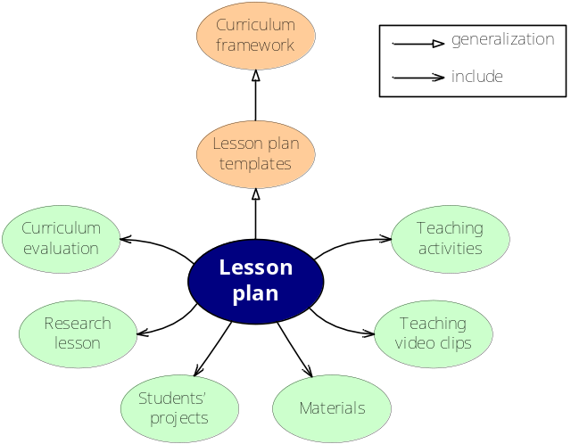
Fig. 1. Lesson plan-centered knowledge-base framework
To incorporate support from different levels of a school into the knowledge-base framework, the diagram shown in Fig. 1 comprises three levels. Curriculum framework belongs to the school level, lesson plan templates belong to the grade level, and lesson plan belongs to the class level. These three layers of the knowledge-base share a generalization relationship. That is, the curriculum development committee at the school level creates the curriculum framework, curriculum development teams at each grade level then design lesson plan templates according to the curriculum framework, and finally teachers at the class level use these templates to design complete lesson plans to suit the needs of their class. Therefore, the knowledge-base is collaboratively constructed based on contributions from the three levels. Teachers can obtain PCK with the help of both vertical and horizontal collaboration.
The 3C-model and web based supporting system EDUPLAN
The proposed knowledge-base framework requires an operation model for teachers to connect related knowledge components and then acquire, regenerate, utilize, and share the knowledge they learned. A supporting system EDUPLAN was also developed for operating the model. In the process of school-based curriculum development, all three levels are involved in the stages of analysis, design, and evaluation to create curriculum content or the knowledge components. Participants in each level must collaborate, communicate and coordinate to develop a consistent curriculum from the top down. Therefore, the three support mechanisms of Creation, Collaboration and Communication, called the 3C-model, are the necessary technological functions that support the three levels (see Fig. 2). The three mechanisms and the corresponding tools are detailed below.
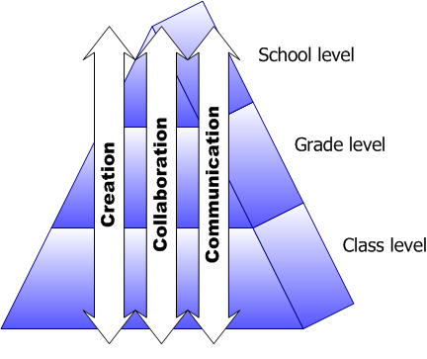
Fig. 2. 3C-model
Creation mechanism
In the 3C-model, the creation mechanism creates a cycle incorporating the three stages of curriculum development, namely the analysis, design, and evaluation (as the ADE cycle shown in Fig. 3), and helps make frequent revisions in creating components of the knowledge-base. In the analysis stage, the model provides functions for different levels of members such as the query and statistics tool and reflective journal searching tool. The query and statistical tool helps users to perform statistical analysis of specific information in lesson plans based on the three dimensions of school years, subjects, and grades; for example, the usage ratios of each ability indictor, the distribution ratio of each subject, instruction hours etc. These functions help teachers to understand past course situations and use them to clarify course continuity and sequence. The function of searching evaluation results in reflective journals can be used to help teachers examine and analyze the evaluation results of authors regarding curriculum framework, lesson plan templates or lesson plans. Teachers then can learn pedagogical content knowledge and curricular knowledge based on past designs and evaluation, and can begin to consider how to design their research lessons. The reflective journal takes the form of notes attached to a lesson plan and can be inputted during the design stage.
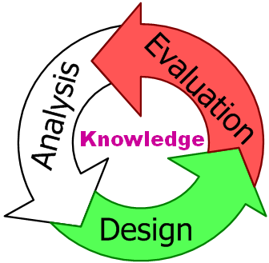
Fig. 3 ADE cycle forms the creation mechanism
In the design stage, the creation mechanism focuses on the special needs of different levels in providing design and management tools to ensure course integration and continuity based on work procedures. At the school level, this mechanism primarily helps the curriculum development committee to design curriculum frameworks. Curriculum frameworks describe course planning implemented by the entire school, including interdisciplinary course topics, overall course objectives and time allocation related to curriculum implementation. At the grade level, this mechanism primarily helps grade and subject representatives to design lesson plan templates. Lesson plan templates describe the simple lesson plans designed by grade level members in reference to the curriculum framework. The content includes instructional standards, knowledge map, subjects taught, formulation of ability indicators and so on. At the class level, this mechanism helps teachers design lesson plans in which they can import lesson plan templates with the help of design tools and design lesson plans that suit the class. Teachers can then be supported by the grade and school levels in designing a research lesson that fits the course objectives. Additionally, the step-by-step designing tool provides an easy method of considering items related to lesson planning during the design stage (see Fig. 4).
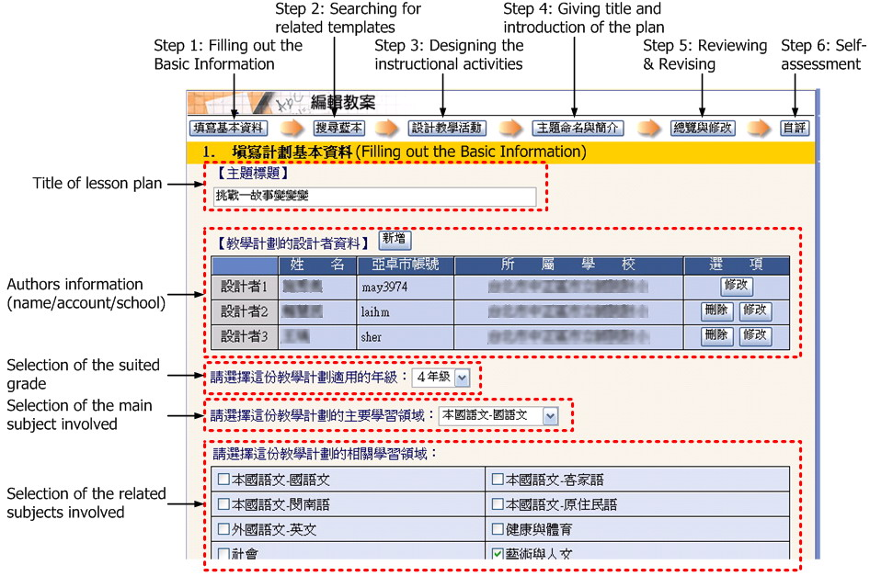
Fig. 4. Step-by-Step Designing tool for class level
In the evaluation stage, the creation mechanism provides different rubric tables to help authors self-review curriculum frameworks, lesson plan templates and lesson plans. Teachers other than the authors of the lesson plans can also use the rubric tables to evaluate the lesson plans of other teachers. Furthermore, the authors of lesson plans can note down new ideas and comments in a reflection journal and make it available to other co-authors as a reference. Finally, the query and statistical tool, as provided during the analysis stage, can help observe quantitative information regarding curriculum design in different dimensions such as year, grade, type of lesson plan, and statistical item.
Collaboration mechanism
The collaboration mechanism links the creation mechanism processes and products of each level, which form an integrated curriculum development procedure. The mechanism not only provides a shared work space, but also links the collaborative space of curriculum development participants on each level of SBCD (see Fig. 5).
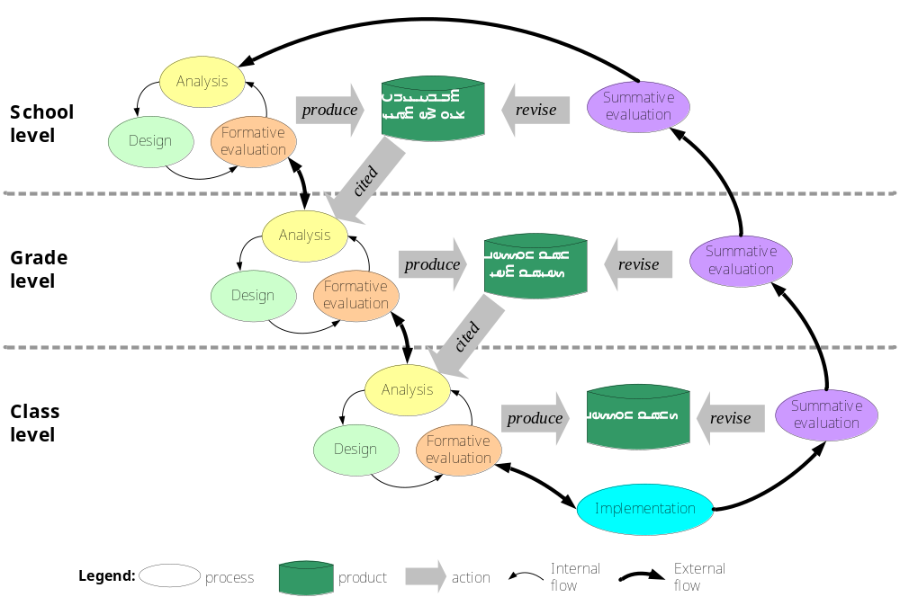
Fig. 5. Connection between shared work space and work procedure in the collaboration mechanism
Although missions differ among the members of each level (school, grade or class, please see Table 1), all members of the three levels must cooperate to complete curriculum development work. Therefore, work spaces must be shared and curriculum development flow must be connected among different levels. Each level of Fig. 4 has its own curriculum development internal cycle (ADE creation mechanism) and output. For example, the school level product is the curriculum framework, the product at the grade level is lesson plan templates, and the product at the class level is the lesson plan itself. Grade levels can cite or refer to the curriculum framework in designing lesson plan templates, and class levels can cite or refer to the lesson plan templates in designing detailed lesson plans (see Fig. 6).
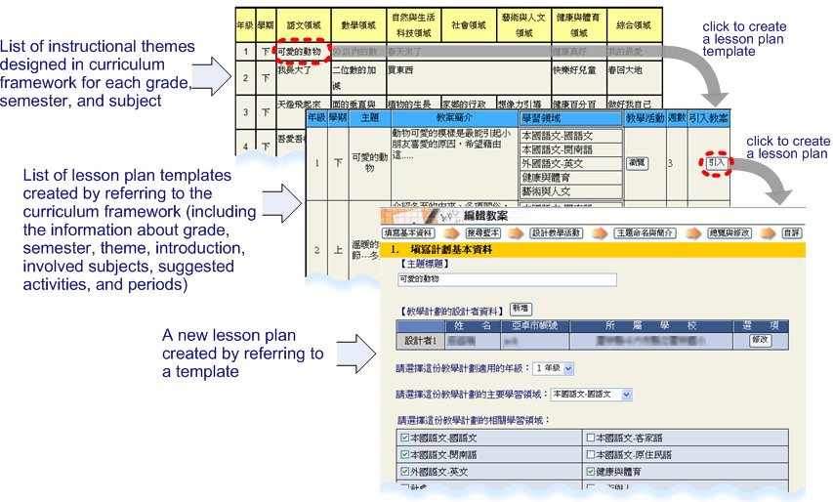
Fig. 6. Authoring tools for collaborative design among three levels
Members of each level are authorized to publicly access the output of each level. All users can assign ratings, express opinions or raise questions in response to the contents of outputs. Teachers can use this mechanism to create, share, and cite other lesson plans in a collaborative manner. The collaboration mechanism also has applications in group setting, and thus teachers interested in collaboration on lesson study can be assigned to the same group, and teachers within that group can then collaboratively design, revise, implement, and evaluate the same lesson plan.
External cycle effectively combines internal cycle and implementation to create a reversible top-down procedure. During the creative process, if revision is required at any level, revision cycles can be performed. During curriculum implementation, collaborative teachers can note down questions and what they have learned in the reflective journal, which is a tool included with each lesson plan. If video recordings of the class exist, they can also be uploaded for inclusion in the lesson plan (see Fig. 7). Additionally, each lesson plan has its own online discussion tool that enables collaborating and observing teachers to discuss instruction related issues. Reflection and discussion after teaching is an important process in lesson study because teachers usually have difficulty observing individual student performance. Observation notes on the instruction and student responses can provide detailed information for future revision.

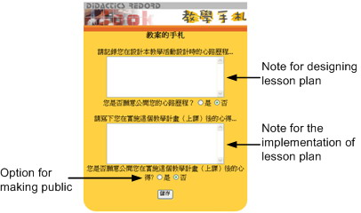
Fig. 7. Reflective Journal for design stage and implementation stage
The summative evaluations of each level are combined in a bottom-up direction of curriculum development. The curriculum requirements of different levels are used as a basis for evaluating lesson plans and related productions. For example, the emphasis in the school level is on whether the lesson plans conform to the curriculum framework in terms of the properties of continuity, sequence, and adaptability. Meanwhile, in the grade level the emphasis is on whether the lesson plans in the same grade possess the properties of integrity and adaptability. Moreover, the emphasis in the class level is on whether lesson plans are adaptable for students in the class. All evaluation contents and revision opinions are detailed to provide a reference for future revision at each level.
Overall evaluation and feedback among three levels (including school, grade, and class) can be implemented with internal and external cycles. The school level can receive the feedback from the grade level, and the grade level can receive the feedback from class level by face-to-face meetings or the communication tools provided in EDUPLAN. Teachers in the class level have the decision-making power to design and implement lesson plans according to the templates designed by the grade level. Similarly, the grade level has the decision-making power to translate and interpret the curriculum framework into various lesson plan templates, and the school level has the decision-making power to create a curriculum framework for all grades. Namely, each level independently acts in its own way in the internal cycle, but the evaluation and feedback are connected as a mechanism to form an integrated curriculum.
In sum, the collaborative mechanism not only provides a collaborative environment for teachers groups and faculties at different levels, but also creates an opportunity for teachers to learn and share pedagogical content knowledge from outside affiliated groups.
Communication mechanism
The communication mechanism is a key mechanism that helps the school faculty communicate information and curriculum via a group discussion system. The mechanism can reduce the time consumed by meetings and discussions, increase the efficiency of exchanging information and data, and further develop various learning communities. Individual teachers can use this mechanism to apply to or join special interest communities at the class level, participate in regular communities at the grade level, for example grade and subject committees, or participate in the School Curriculum Development Committee (see Fig. 8).
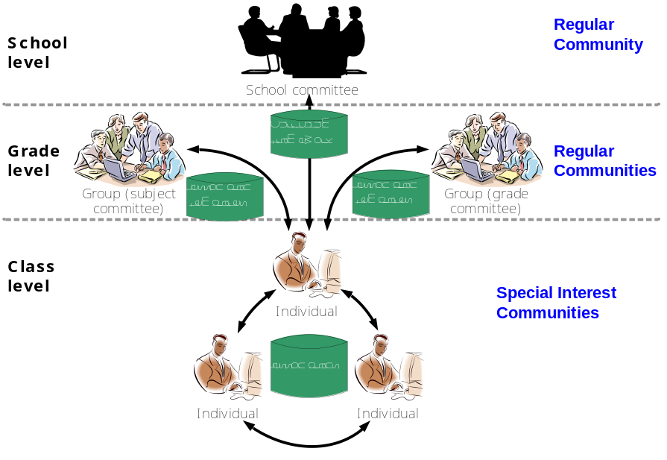
Fig. 8 Communication mechanism
This mechanism provides a free discussion space for each lesson plan. When one or a group of teachers collaboratively design a lesson plan, other interested teachers can use this specialized discussion space to exchange information with the designers regarding lesson planning, implementation, and evaluation. Such learning communities, called special interest communities, generally comprise lesson study groups and are also the fundamental communities for PCK development. Regular communities are established according to school curriculum development strategies. Generally Taiwanese schools have two types of communities, the school committee for curriculum development and the grade or subject committee for curriculum development for each grade. The communication mechanism provides regular communities with the discussion group tool and mailing list. Although these tools are common, the EDUPLAN can provide different related information in the form of hints and references based on different communities in response to users posting information.
Evaluation
The web-based system EDUPLAN (available online at http://eduplans.educities.edu.tw/) is implemented by the PHP programming language and MySQL database management system on an Apache WWW server. EDUPLAN is an electronic performance support system that mainly supports teacher development of PCK according to the proposed knowledge-base framework and the operation of the 3C-model. Hence, the evaluation is focused on the feasibility and performance of the 3C-model and EDUPLAN in supporting teachers’ PCK development. The target users also focus on the teachers.
Evaluation topics
This study considers three evaluation topics:
- Can the 3C-model improve teacher performance in developing PCK?
- Can the 3C-model facilitate teacher collaboration in developing curriculum and PCK?
- Can the supporting tools constructed based on the three mechanisms enhance the performance of the PCK development of teachers?
Participants
The proposed 3C-model and EDUPLAN have been applied experimentally in a primary school in Taiwan. The school comprised 58 classes (with each grade having 8 to 11 classes), 110 teachers and over 1900 students. Generally, each grade contains two or three class groups that collaborate on curriculum development and lesson study; that is, each group contains four or five classes. The present experiment did not compel participants to collaborate with others. Of the 110 teachers at the school chosen for the experiment had 110 teachers, 77 were interested in enrolling in the experimental project, and finally 69 were willing to participant in the evaluation activities, including seven teachers who were the members of the School-based Curriculum Development Committee, 12 teachers who were grade representatives, and 50 general teachers. All 69 participants are the main subjects throughout all research stages. The subsequent research results and discussion also correspond to the responses from the 69 participants.
Methodology
The evaluation used the database statistics, questionnaires, and interviews with focus group to gather participant responses. The experiment was conducted over a one year period, but statistical data on the system database were continuously collected over two years, from Aug. 2003 to Aug. 2005. The research procedure comprised three stages, as follows.
- Preparation (4 months). The main tasks during this stage include: (1) holding workshops to train participants to understand the proposed model of SBCD and the lesson study procedure, and familiarize themselves with the operation of the supporting system EDUPLAN; (2) holding many small group discussions for each level to guide the participants in thinking about how EDUPLAN can be used for school-based curriculum development; and (3) gathering suggestions regarding EDUPLAN for system developers.
- Implementation (7 months). The participants from different levels used EDUPLAN to develop a school curriculum which is combined with the lesson study based on the 3C-model. The main procedures for the creation mechanism are: first, the members of the school committee of SBCD develop the curriculum framework for the whole school; second, the members of each grade committee of SBCD design numerous lesson plan templates for their grade by referring to the curriculum framework; and finally, teacher groups collaboratively design lesson plans by referring to the lesson plan templates. Following the curriculum design, selected lesson plans were implemented in classrooms and observation notes were recorded for further discussion by observers or by the teachers themselves using the reflective journal writing tool. Finally, all participants evaluate and discuss their practices taught via face-to-face group meetings or communication tools provided by EDUPLAN.
- Data collection and survey (from Aug. 2003 to Aug. 2005). Observations and interviews are first conducted to examine the practicability and efficiency of the 3C-model and supporting system EDUPLAN during the experiment. Second, the quantities and quality of all products are analyzed based on the statistics from the database created during the experiment. Third, the research group applies a questionnaire survey (using a five-point Likert scale, in which 1=strongly disagree or poor and 5=strongly agree or excellent) to evaluate the model and EDUPLAN based on the participant perspectives. Finally, 14 teachers from the three levels are chosen as the focus group for an interview.
Results and discussions
The research questions are evaluated below based on results of database statistics, questionnaires, and interviews.
Question 1: Can the 3C-model improve teacher performance in developing PCK?
Teacher performance in developing PCK can be observed from the quantity of designed lesson plans, since lesson plans comprise all activities and teaching materials. That means lesson plans can be seen as the vehicle of teacher PCK. Therefore, this study considers the quantity of both curriculums and lesson plans as an index of PCK quantity. In the past, the school curriculum development committee designed the curriculum framework to provide guidance for teachers in designing lesson plans for use in their classes. However, based on the interview with the focus group, most teachers taught, in the past, by following the lesson plans designed by the textbook authors or simply relied on their own past experience without using any lesson plan. However, in this evaluation, the school participants generated a curriculum framework, 34 lesson plan templates, and 152 lesson plans during the experiment. The stable production of lesson plans demonstrated that teachers gradually accepted the stratified SBCD as a method of PCK development (see Fig. 9). Additionally, in order to observe changes in behavior of participants in developing the curriculum and PCK, promotional activities were stopped after Aug. 2004. Inspiringly, the production of lesson plans from Oct. 2004 to Sep. 2005 (=77) was found to exceed that from Oct. 2003 to Sep. 2004 (=53), indicating that teachers were actively and continuously using the EDUPLAN to design lesson plans even without promotion by researchers.
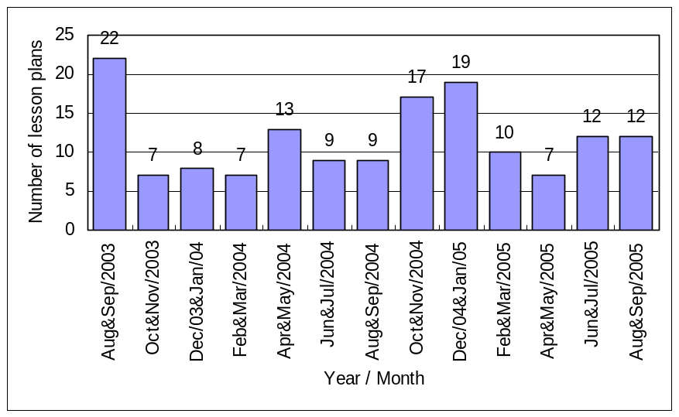
Fig. 9. Bimonthly quantity of lesson plans from Aug. 2003 to Sep. 2005.
Unlike previously, the school achieved strong progress on teacher awareness of teaching methods. The 3C-model reduced barriers to teachers developing pedagogical content knowledge. From the questionnaire, across all three levels 89.8% of participants (weighted average=4.18) agreed or strongly agreed that the 3C-model helped them to develop their pedagogical content knowledge (see Fig. 10).
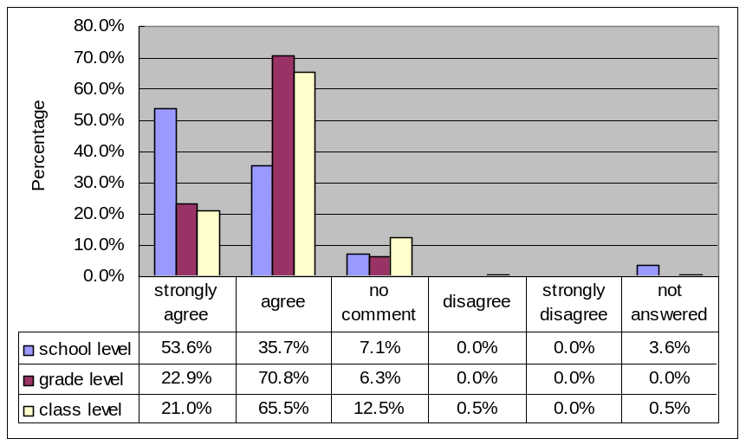
Fig. 10. The degree of agreement about the help of 3C-model upon teacher’s PCK
Additionally, the percentage of strong agreement for school level (=53.6%) is much higher than for grade level (22.9%) and class level (21.0%). The difference demonstrates that the school curriculum development committee better understood that the stratified SBCD can help teachers to develop PCK. In an interview, the members of the school curriculum development committee explained that the 3C-model not only enhanced teacher motivation to continuously develop their PCK but also facilitated the action of SBCD which made it difficult to convince teachers of involving the SBCD activities in the past.
Following an interview with the focus group, we found most class level interviewees gradually established a stable process for developing their PCK, including idea proposition, design, implementation, evaluation, and modification. Moreover, the step-by-step designing guidance helped teachers discover problems and practice instructional research or experiment without missing the orientation towards the instructional objectives. Three interviewees explained how they appreciated the 3C-model, as follows.
We cannot see how courses were connected to create a whole school-based curriculum if we simply design the lesson plans individually, but we can see the whole structure via integral and stratified curriculum planning. (Jun. 25, 2004)
Numerous instructional problems were identified during lesson plan design, and more was learned from partners about instruction methods for overcoming those problems. (Jun. 25, 2004)
During lesson plan design, we not only learned pedagogical content knowledge but in fact learned even more about other knowledge, such as how to design an instructional activity, how to evaluate student learning achievement, how to deal with emergencies, and so on. (Jun. 25, 2004)
The grade level interviewees also benefited from the 3C-model and learned how to realize the vision of their school for students by reorganizing a mass of subject matters and selecting appropriate learning and teaching themes. Two interviewees described their feelings as follows.
The School Curriculum Committee has establishes instructional themes with indicators of ability that students must achieve, and included these themes in a structural diagram. The grade representatives reorganized subject matter, considered the involvement of multiple disciplines, and then designed lesson plan templates that provided a useful means for teachers to design lesson plans for their classes. We learned much more than before. (Jun. 25, 2004)
This model helped teachers focus on how to apply their pedagogical content knowledge in the classroom. Teachers did not need to consider problems regarding the articulation and integration of curriculum the indicators of ability the students have to achieve. (Dec. 20, 2004)
School curriculum committee fulfills an administrative role and naturally promotes the professional development of teachers. This committee appreciated the adoption of the 3C-model owing to its ability to overcome barriers in design, evaluation, communication and management. Some reasons are given below.
I think a teacher cannot consider too many things in lesson planning. She needs a resource base, such as the academic research base dedicated to curriculum development designed to help teachers. (Dec. 22, 2004))
Teachers can use the stratified development model to imitate those templates and also implies the guidance for lesson planning. Additionally, we can easily understand the developing situation of each teacher through the EDUPLAN and communicate with them anytime and anywhere. (Jun. 9, 2005)
To summarize, there were four main reasons for why participants strongly agreed that the 3C-model could effectively enhance teacher PCK. First, the model which took advantage of lesson planning with their daily work offered a more effective means of PCK development. Second, web-based tools which can be used anytime and anywhere enable teachers to work on and research curriculum development more efficiently. Third, the 3C-model enables teachers to investigate subject matter and pedagogy with other faculties. Finally, school curriculum development activities place teachers under pressure to work with colleagues.
Question 2: Can the 3C-model facilitate teacher collaboration in developing curriculum and PCK?
The database statistics indicate that 50.7% of lesson plans have collaborative authors and each lesson plan has an average of 2.1 co-authors. Although the total number of lesson plans with multiple authors (=77) almost equaled the total number of lesson plans with a single author (=75), based on a long-term view the monthly production of lesson plans with multiple authors gradually exceeded that of plans with a single author (see Fig. 11). Additionally, this trend only began from Aug. 2004, which was also the date when the researchers stopped actively promoting the use of the EDUPLAN. The direction demonstrates that the 3C-model help increased numbers of teachers to collaborate in developing curriculum and PCK.
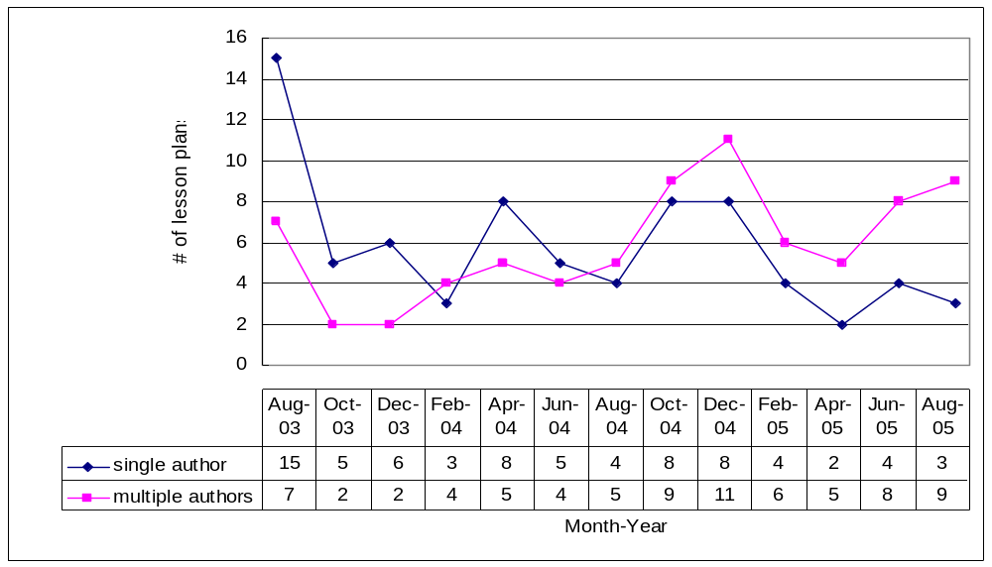
Fig. 11. Production of lesson plans designed by single author or multiple authors
Based on the questionnaire, when teachers were asked about the satisfaction with the five collaboration tools provided by the EDUPLAN, most teachers responded that the tools could promote collaboration in curriculum design and lesson study (see Table 2). Besides the importing tool, this study also found that the weighted averages of degree of satisfaction for the other four tools decrease progressively from grade level to class level. Based on the interview with the focus group, the school level interviewees expressed their appreciation for the collaborative mechanism, and that the associated tools provided them with an excellent opportunity to promote teacher professional development activities, which historically had been difficult to persuade teachers to become involved in. The interviewees conducted at the grade level expressed that, given that they fulfilled intermediate role between school and class level, they liked to use the collaborative tools but that face-to-face discussion could sometimes be more efficient than the tools. Additionally, some interviewees from the class level preferred to use traditional methods for lesson study.
Table 2. The weighted averages of each level’s satisfactory degree for the five collaboration tools
N=69  (School level=7, Grade level=12, Class level=50) | School level | Grade level | Class level
Importing tool for lesson plan template or curriculum framework can support collaboration among different levels. | 4.29 | 3.67 | 4.12
Group setting can support setup and management of collaborative groups. | 4.43 | 4.00 | 3.90
Authoring tool for lesson plan templates can support grade level to design simple instances for class level. | 4.57 | 4.33 | 4.16
Lesson plan searching tool can provide groups with a quick search for other related plans. | 4.57 | 4.17 | 4.04
Discussion tool for each lesson plan can support communication in collaborative design and reflection. | 4.14 | 4.00 | 3.98
Average | 4.40 | 4.03 | 4.04
Note: the weighted averages of satisfactory degree were calculated by the following point distribution:
5: strongly agree, 4: agree, 3: no comment, 2: disagree, 1: strongly disagree, and 0: not answered.
Additionally, the degree of satisfaction with the importing tool for grade level (=3.67) was lower than for the other two levels. The grade level interviewees noted it was difficult to design a lesson plan template simply by importing the curriculum framework. The interviewees had to review many learning materials and integrate comments from other colleagues to create appropriate lesson plan templates for most teacher requirements.
Based on the interview with the focus group, the interviewees from school and grade level expressed that the internal cycle of the collaborative mechanism provides horizontal collaboration among teachers who teach in the same grade or subject, while the external cycle provides vertical collaboration among teachers and administrative faculties involved in curriculum development. The following excerpts represent this advantage.
The school curriculum development committee created instructional themes that included OR incorporating indicators of ability that students must achieve before the summer vacation, and provided these themes to teachers for collaboratively designing lesson plans with other teachers. Teachers can easily design lesson plans and stress the research on teaching materials and related pedagogy. (Quoted from a school level interviewee on Jun. 25, 2004)
The model facilitates not only collaboration among teachers, but also collaboration between teachers and policymakers involved in curriculum development. (Quoted from a grade level interviewee on Jun. 25, 2004)
At the class level, the collaboration mechanism with corresponding supporting tools enabled teachers to discuss pedagogical content knowledge with their partners in depth. Two interviewees said:
The discussion system enables the posting of numerous comments by each grade and administrative faculty, increasing the efficiency of meetings for instructional reflection and curriculum integration. (Jun. 25, 2004)
Since we have common goals, we spent more time than previously talking with other teachers, promoting mutual understanding, further collaboratively researching lessons, and obtaining numerous experiences we previously did not possess. (Jun. 25, 2004)
This study also found that the participants engaged in SBCD were more willing to collaborate with teachers at different grades than those not yet engaged in SBCD. More pedagogical content knowledge is naturally shared during the curriculum development process than other professional development activities. These results also indicate that leadership and institutional support can facilitate increased collaboration in developing curriculum and teacher PCK.
Question 3: Can the supporting tools constructed based on the three mechanisms enhance the performance of the PCK development of teachers?
To survey this question, a questionnaire was taken to evaluate the supporting tools of the three mechanisms by asking how these tools can help teachers improve the development of PCK. The results for the creation mechanism, collaborative mechanism and communication mechanism tools are listed in Tables 3, 2, and 4 respectively. Since the results for the collaboration mechanism have been discussed in Question 2, the following deals with the results and discussion for the creation and communication mechanisms.
In the questionnaire results of creation mechanism (in Table 3), all supporting tools received positive agreement, especially the lesson plan designing tool that gained higher appreciation than the others. The designing tool provides a step-by-step design procedure and a format that teachers were familiar with. The following quotations from the interview with the focus group express the advantages of the tool.
The format used for lesson plan designs is a clear format like the handwritten table we used before. The step-by-step procedures and web-based form help in quickly understanding how to design a lesson plan, helping teachers focus all their energies on designing the lesson itself. (Dec. 22, 2004)
I don’t have to seek the indicators of ability used in my lesson plan one by one. Instead I can simply browse and check the detailed items of indicators I need, saving me considerable tedious work. (Dec. 22, 2004)
During the design phase, the related materials, lesson plans, and references, such as web pages, can be conveniently searched simply by inputting a keyword. (Dec. 22, 2004)
The discussion tool for each lesson plan creates an opportunity for the exchange of different opinions regarding pedagogy. (Dec. 22, 2004)
The weighted averages of degree of satisfaction with the reflective journal are lower than the other tools involved in the creation mechanism. During the focus group interview, some interviewees expressed they did not know how to use the tool to help themselves design lesson plans. Consequently, both the guidance and the operating interface require improvement.
Table 3. The weighted averages of satisfactory degree for the tools of creation mechanism
N=69  (School level=7, Grade level=12, Class level=50) | School level | Grade level | Class level
Heuristic and procedural lesson plan designing tool can support for idea generation and proposition. | 4.43 | 4.25 | 4.14
Searching tool for indicators of ability can support for comparing and selecting appropriate teaching goals. | 4.00 | 3.83 | 4.28
Reflective journal can support for recording the course of design and the problems encountered. | 3.71 | 3.42 | 3.62
Rating tool can support for the formative and summative evaluation of lesson plans. | 3.86 | 3.67 | 3.74
Statistic tool can support for the analysis and evaluation of lesson plans. | 4.14 | 4.17 | 3.94
Average | 4.03 | 3.87 | 3.94
Note: the weighted averages of satisfactory degree were calculated by the following point distribution:
5: strongly agree, 4: agree, 3: no comment, 2: disagree, 1: strongly disagree, and 0: not answered.

Table 4. The weighted averages of satisfactory degree for the tools of communication mechanism
N=69  (School level=7, Grade level=12, Class level=50) | School level | Grade level | Class level
Reflective journal can support communication between co-authors. | 3.86 | 3.50 | 3.58
Discussion tool for each lesson plan can support for communication between co-authors and browsers. | 3.86 | 3.33 | 3.64
Message tool for co-authors can support for communication among co-authors. | 4.29 | 3.58 | 3.98
Discussion tool for all provides a forum for each subject domain. | 4.71 | 4.33 | 3.96
Average | 4.18 | 3.69 | 3.79
Note: the weighted averages of satisfactory degree were calculated by the following point distribution:
5: strongly agree, 4: agree, 3: no comment, 2: disagree, 1: strongly disagree, and 0: not answered.
Table 4 indicates that the weighted averages of the degree of satisfaction regarding the reflective journal and discussion tool for each lesson plan are lower than those for the other communication tools, although the original purpose of these two tools is to support communication at the same level and among different levels during the curriculum design and implementation. Some interviewees stated in the interview with the focus group, that they used to accumulate information from the Internet to design lesson plans, and post them by the communication tools, but would rather discuss that information with co-authors via email or face-to-face. Meanwhile, the two tools were not often used for communication between co-authors and browsers, because they are not convenient for discussing the critical problems or operations of curriculum design. Interviewees also stated that the face-to-face meeting was more efficient than asynchronous discussion via the communication tools, since they could see and feel each other’s emotional expressions. In summary, the communication tools can function as an information exchange center to facilitate real discussion in face-to-face meetings.
Additionally, the school level gave the discussion tool for all a high satisfaction degree (see Table 4) since they believed this tool provided three key interaction functions: first, the school curriculum development committee can explain and promote what the curriculum framework was designed for; second, the categorized discussion forums can gradually form learning communities of practice for each subject domain; finally, the school committee can easily and rapidly receive teacher comments from different perspectives and thus increase curriculum development efficiency.
On the whole, the interviews indicated that most teachers appreciated EDUPLAN as a means of developing and improving their PCK by curriculum development activities. Two interviewees of grade and school level respondents reached the following conclusions.
Generally, we have established a consensus that we should use the system while designing lesson plans and researching lessons. (Grade level on Dec. 22, 2004)
The main advantage of EDUPLAN is that you can store and collect teaching documents anytime and anywhere and do not need to carry them with you. (School level on Dec. 22, 2004)
In short, technology not only creates a convenient working environment but is a catalyst for connecting people who share the same research interests, and then the learning behavior improves. However, we believe that no powerful technological work can work in an organization if it lacks an appropriate operation model. The 3C-model helps EDUPLAN work well because it shares tasks of curriculum development among different levels and allows teachers to focus on teaching related issues. The system also helps connect knowledge from different levels. Teachers can easily design and realize pedagogy by creating lesson plans based on the contribution from other colleagues.
Conclusions and recommended studies
Teacher professional development has stressed the research-based activities by employing classroom practices such as lesson study; the affordance of digital technology can help in generating and sharing pedagogical content knowledge. However, most current computer-supported systems for PCK development are dedicated to individual teachers or groups of teachers. Opportunities for support from the leadership and institutional resources of the school thus are reduced. This study proposed a professional development model for PCK based on school-based curriculum development. The proposed model engaged teachers in collaboratively constructing and sharing a knowledge-base of lesson plans for the curriculum of their school. We found such design has following advantages from the evaluation results:
- Through stratified school-based curriculum development activities, teachers who participate in different levels of committees can contribute their experience to inspire PCK generation in classroom practices. Since all faculties must participate in curriculum development, this strategy creates a climate of school-wide professional development, which not only advances teacher participation and enriches the content of the lesson plan-centered knowledge-base, but also facilitates the success of curriculum development. That is, both teacher PCK and school curriculum are developed together during SBCD.
- The 3C-model with supporting tools can help teachers blend their research into daily practice via lesson planning, and provides an opportunity for teachers to collaborate with others at different levels, so the teachers who want to perform action research or lesson study in their classes can receive help and corresponding knowledge to enhance the research efficiency.
- The layered structure of lesson plan-centered knowledge-base makes it possible to integrate related knowledge components into a special form during the various stages of curriculum development, namely analysis, design, implementation and evaluation. Teachers thus are inspired to generate more diverse ideas regarding teaching innovations, and also to help externalize their tacit knowledge. Thus, content knowledge, especially the PCK, can be easily managed using information technology.
- The three mechanisms of the 3C-model facilitate increased collaboration among teachers from different levels of curriculum development. The members of the school and grade levels can provide fundamental guidance regarding lesson plan design so that the plans conform to school curriculum goals and student background. Teachers are more willing to collaborate with other teachers from different levels and involved in teaching different subject domains. Restated, leadership and institutional support can facilitate increased collaboration in developing curriculum and then teacher PCK.
- Based on the step-by-step and circular process of design, implementation, discussion, and reflection on lesson plans, teachers increased their awareness that teaching demands more pedagogical content knowledge.
- The degree of satisfaction of the supporting tools gradually reduces from the school level to the class level, making the members of the school curriculum development committee more appreciate of the use of ICT in teacher professional development activities. Meanwhile, teachers at the class level are more aware of professional autonomy and wish to control more variables.
The 3C-model and the proposed EDUPLAN system have gained a significant positive effect for teachers in developing PCK. Some reflections and comments from the results of this study are provided for future reference.
- The grade-level members complained that lesson plan templates were hard to design simply by importing the curriculum framework. They play an intermediate role between the school and class levels, and thus have to faithfully interpret the curriculum framework, and innovatively design suitable templates with many requirements. Therefore, the expert teachers or seniors could be chosen as grade representatives, and some educational experts or professors could be invited as the advisors on their works.
- Teachers prefer to discuss lesson planning with co-authors face-to-face, since the provided communication tools are not convenient when discussing the critical problems or works of curriculum design. These tools are only the supporting roles for efficient communication. The face-to-face meetings can be more efficient than the tools in real-time communication, while tools could help asynchronous discussion and storing of all posted information, thus providing a rich source of discussion material.
- Some participants in the experiment expressed low satisfaction with the use of the Reflection Journal to design lesson plans. Both the guidance and the operating interface need improvement according to the focus group interview.
Finally, some research issues for future studies in using curriculum development as a vehicle of teacher development of PCK have also arisen after the utilization of the 3C-model.
- Although the stratified curriculum development strategy has advantages, it remains a challenge to balance the teacher’s innovative instruction or research lessons in accordance with the goals of school-based curriculum development.
- Most teachers, even members of the SBCD committee, lack sufficient curricular knowledge, so that the efficiency of professional development of PCK is influenced by the slow process of curriculum development.
- The content of lesson-plan-centered knowledge-base has emphasized the PCK embedded in lesson plans, leading to the relative neglect of other professional knowledge, such as student behavior coaching, parenting education, classroom management, educational research methods, etc.
- Copyright problems may occur while a teacher tailors other lesson plans by appending their own new ideas to them. Also, teachers may be reluctant to share designs and lesson plans in a public network space owing to copyright issues.
- Besides the system itself, some educational issues can be studied in the future when applying the 3C-model and EDUPLAN in a school. These include how teachers interact with partners and computers; how teachers learn or improve their PCK through lesson planning, how to extend the application of resources in lesson plans as learning materials for students, and whether and how the model and system can be a means of teachers’ personal knowledge management.
In conclusion, unlike other professional development models, which focus only on supporting individual teachers or teacher groups, the proposed 3C-model engages teachers to develop their own PCK through a school-wide activity. Teachers can study their pedagogies and materials spontaneously by designing, implementing and reflecting lesson plans for a school-based curriculum with institutional support and appropriate leadership from the school. A performance support system can effectively support teachers’ professional development if the system is applied through an appropriate model, such as the 3C-model in current study. Future studies concerning other educational issues and system functions should consider the extended demands and derived problems in developing the applied model and its corresponding performance support system.
References
Ball, D. L., & Cohen, D. K. (1996). Reform by the book: What is – or might be – the role of curriculum materials in teacher learning and instructional reform? Educational Researcher, 25(9), 6-8, 14.
Barab, S., Makinster, J. G., Moore, J. A., Cunningham, D. J., & The ILF Design Team. (2001). Designing and Building an On-line Community: The Struggle to Support Sociability in the Inquiry Learning Forum. Educational Technology Research & Development, 49(4), 71-96.
Barnett, M (2002). Issues and trends concerning new technologies for teacher professional development: a review of the literature. Annual Meeting of the American Educational Research Association, New Orleans.
Borko, H., Livingston, C., McCaleb, J. & Mauro L. (1988). Student teachers’ planning and post-lesson reflections: patterns and implications for teacher preparation. In J. Calderhead (Ed.), Teachers’ Professional Learning. New York: The Falmer Press.
Bullough, R. V. & Gitlin, A. D. (1991). Educative communities and the development of the reflective practitioner. In B. R. Tabachnick & Zeichner (Eds.), Issues and practices in inquiry-oriented teacher education. New York: The Falmer Press.
Cochran, K. F, DeRuiter, J. A., & King R. A. (1993). Pedagogical content knowing: an integrative model for teacher preparation. Journal of Teacher Education, 44(4), 263-272.
Collopy, R. (2003). Curriculum materials as a professional development tool: How a mathematics textbook affected two teachers’ learning. The Elementary School Journal, 103(3), 287-311.
Confrey, J. (1990). A review of the research on student conceptions in mathematics, science, and programming. In C. B. Cazden (Ed.), Review of research in education, Vol. 16, Washington, DC: American Educational Research Association.
Corno, L. & Snow, R. E. (1986). Adapting teaching to individual differences among learners. In M. C. Wittrock (Ed.), Handbook of research on teaching (3rd ed.). New York: Macmillan.
Elliott, J. (1991). Action research for educational change. Philadelphia: Open University Press.
Fernandez, C. (2002). Learning from Japanese approaches to professional development: The case of lesson study. Journal of Teacher Education, 53(5), 393-405.
Fernandez, C., & Chokshi, S. (2002). A practical guide to translating lesson study for a US setting. Phi Delta Kappan, 84(2), 128-134.
Fernandez, C., Cannon, J., & Chokshi, S. (2003). A U.S.-Japan lesson study collaboration reveals critical lenses for examining practice. Teaching and Teacher Education, 19(2), 171-185.
Fisher, T., Higgins, C. & Loveless, A. (2006). Teachers learning with digital technologies: a review of research and projects. FutureLab Series Report 14, FutureLab press. Accessed from: http://www.futurelab.org.uk/research/reviews/14_01.htm on Dec. 14, 2006.
Frost, D. (1996). Integrating enquiry into teachers’ professional lives. In McBride, R. (Ed.), Teacher education policy: some issues arising from research and practice. London: Falmer Press.
Grossman, P. L. (1989). A study in contrast: sources of pedagogical content knowledge for secondary English teachers. Journal of Teacher Education, 40(5), 24-31.
Heaton, R. M. (2000). Teaching mathematics to the new standards: Relearning the dance. New York: Teacher College Press.
Hewson, P. W. & Hewson, M. G. (1989). Analysis and use of a task for identifying conceptions of teaching science. Journal of Education for Teaching, 15(3), 191-209.
Hiebert, J., Gallimore, R., & Stigler, J. W. (2002). A knowledge base for the teaching profession: what would it look like and how can we get one? Educational Researcher, 31(5), 3-15.
Lampert, M., & Ball, D. L. (1998). Teaching, multimedia, and mathematics: Investigations of real practice. New York: Teachers College Press.
Lederman, N. G. & Latz, M. (1993). Emergence and Interactions of knowledge structures in the preservice teacher. Paper presented at the Annual meeting of the National association for Research in Science Teaching. Atlanta, Georgia.
Lewin, K. (1946). Action research and minority problems. Journal of Social Issues, 2, 34-46.
Lewis, C. & Tsuchida, I. (1998). A lesson is like a swiftly flowing river: How research lessons improve Japanese education. American Educator, 22(4), 12-17, 50-52.
Lewis, C. (2002). Does Lesson Study Have a Future in the United States? Nagoya Journal of Education and Human Development, January 2002, No. 1, 1-23.
Lewis, C., Perry, R. & Murata, A. (2003). Lesson study and teachers’ knowledge development: Collaborative Critique of a research model and methods. Report on Annual meeting of the American Educational Research Association in Chicago, IL, Apr. 2003. ERIC: ED478172.
Lewis, C., Perry, R. & Murata, A. (2006). How should research contribute to instructional improvement? The case of lesson study. Educational Researcher, 35(3), 3-14.
Marks, R. (1990). Pedagogical content knowledge: From a mathematical case to a modified conception. Journal of Teacher Education, 41(3), 3-11.
Marsh, C., Day, C., Hannay, L. and McCutcheon, G. (1990). Reconceptualizing School-based Curriculum Development, London: Falmer.
Marx, R. W., Blumenfeld, P. C., Krajcik, J. S., & Soloway, E. (1998). New technologies for teacher professional development. Teaching and Teacher Education, 14(1), 33–52.
Matoba, M. & Arani, M. R. S. (2005). Transnational Learning: A Review of Lesson Study in Japan. Paper presented in 1st Annual Conference on Learning Study. Retrieved Aug. 8, 2006 from http://www.ied.edu.hk/clasp/lsconference/1st/abstract.html.
McDiarmid, G. W., Ball, D. L., & Anderson, C. W. (1989). Why staying one chapter ahead doesn’t really work: Subject-specific pedagogy. In M. Reynolds (Ed.), Knowledge base for the beginning teacher. Oxford: Pergamon Press.
McEwan, H. & BuIl, B. (1991). The pedagogical nature of subject matter knowledge. American Educational Research Journal, 28(2), 316-334.
Putman, R., & Borko, H. (2000). What do new views of knowledge and thinking have to say about research on teacher learning? Educational Researcher, 29(1), 4–15.
Remillard, J. T. (1999). Curriculum materials in mathematics education reform: A framework for examining teachers’ curriculum development. Curriculum Inquiry, 29(3), 315-342.
Reynolds, A. (1992). What is competent beginning teaching? A review of the literature. Review of Educational Research, 62(l), 1-35.
Rudduck, J. (1992). Practitioner research and programs of initial teacher education. In T. Russell & H. Munby (Eds.), Teachers and teaching: From classroom to reflection. London: The Falmer Press.
Schon, D. A. (1983). The reflective practitioner: How professional think in action. New York: BasicBooks.
Schratz, M. (1993). Through the looking glass: The use of associative methods to enhance teacher thinking. In J. Elliott (Ed.), Reconstructing Teacher Education: Teacher Development. London: The Falmer Press.
Shulman, L. S. & Shulman, J. H. (2004). How and what teachers learn: a shifting perspective. Journal of Curriculum Studies, 36(2), 257-271.
Shulman, L. S. (1986). Those who understand: Knowledge growth in teaching. Educational Researcher, 15(2), 4-14.
Shulman, L. S. (1987). Knowledge and teaching: Foundations of the new reform. Harvard Educational Review, 57(1), 1-22.
Skilbeck, M. (1984). School-based curriculum development. London: Harper & Row.
Somekh, B. (1991). Collaborative action research: Working together towards professional development. In C. Biott (Ed.) Semi-Detached teachers: Building support and advisory relationships in classrooms. London: The Falmer Press, 1991.
Somekh, B. and Davis, N. (eds) (1997). Using Information Technology Effectively in Teaching and Learning. London: Routledge.
Stenhouse, L. (1975). An Introduction to Curriculum Research and Development. London: Heinemann.
Stigler, J., & Hiebert, J., (1999). The teaching gap. New York: The Free Press.
Tamir, P. (1988). Subject matter and related pedagogical knowledge in teacher education. Teaching and Teacher Education, 4(2), 99-110.
Tamir, P. (1990). Teachers knowledge. In T. Husen & T. N. Postlethwaite (Eds.), The international encyclopedia of education. Supplementary Vol. Two. Oxford: Pergamon Press.
Tobin, K., Tippins, D. J., & Gallard, A. J. (1994). Research on Instructional Strategies for Teaching Science. In Gabel, D. (Ed.), Handbook of Research on Science Teaching and Learning. New York: Wacmillan Publishing company.
Villegas-Reimers, E. (2003). Teacher professional development: an international review of the literature. Paris: UNESCO: International Institute for Educational Planning.
Visibility Platform, LessonLab, a division of Pearson Education, VisibilityTM — LessonLab's Proprietary Technology Platform, retrieved Aug. 30, 2006 from http://www.lessonlab.com/visibilityplatform/overview.cfm
Watanabe, T. (2002). Learning from Japanese lesson study. Educational Leadership, 59(6), 36-39.
Wideen, M. F. (1992). School-based teacher development. In Fullan, M. & Hargreaves, A. (Eds), Teacher development and educational change. London: The Falmer Press.
Willis, S. (2002). Creating a knowledge base for teaching: a conversation with James Stigler. Educational Leadership, 59(6), 6-11.
Wilson, S. M., Shulman, L. S., & Richert, A. E. (1987). “150 different ways” of knowing: Representations of knowledge in teaching. In J. Calderhead (Ed.), Exploring teacher’s thinking. Eastbourne, England: Cassell.
Wiske, M. S., Sick, M., & Wirsig, S. (2001). New technologies to support teaching for understanding. International Journal of Educational Research, 35(5), 483-501.

